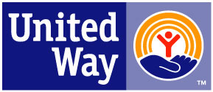
Harvey County United Way
Program Progress Report – April 1, 2020 – March 31, 2021

Report Due: May 15, 2021 (email to harveyunitedway@gmail.com)

Name of Funded Program: __________

Organization Name (if different): _______

Contact Person: _____________________________________ Phone: ________________

***NOTE: REPORT MUST BE LIMITED TO ONE PAGE***

OUTPUT: # served

(explanation if needed)

PROGRESS

MADE TO

OUTCOMES

(refer to original grant application for stated outcomes)

BARRIERS EXPERIENCED AND HOW THEY ARE BEING ADDRESSED

ACTIVITIES TO

SUPPORT HCUW

ANNUAL CAMPAIGN

